

**Database Systems Project Part III**

**Logical Schema Optimization and Machine Learning Model Creation**

**Course Title:** Database Systems **Course Number:** CSCI-GA.2433-001

**Instructor:** Jean-Claude Franchitti

**Team Members:**

|  |  |  |
| --- | --- | --- |
| **Name:** Dedeepya Guntaka  **Net ID:** dg4489  **NYU ID:** N18304471 | **Name:** Shivam Dheer  **Net ID:** sd6080 **NYU ID:** N18103074 | **Name:** Varun Putta  **Net ID:** vsp7221  **NYU ID:** N10489122 |

**Database Systems Project Part III: Logical Schema Optimization and Machine Learning Model Creation**

***Project Objective:*** *Designing an Enterprise Data Architecture for Integrated, Scalable, and Governed Data Management to Predict and Reduce Employee Attrition.*

**Problem Statement**

Employee attrition is a significant challenge, affecting productivity, morale, and costs. This project aims to design a comprehensive EDA that enables efficient data management across traditional storage systems and supports predictive analytics to identify high-risk employees likely to leave. The company can tailor interventions that improve employee retention, optimise workplace conditions, and mitigate attrition-related costs by leveraging a structured data environment.

**Ongoing Project Background**

The ongoing project, which aims to design an **Enterprise Data Architecture (EDA)**, is a continuation of efforts to address the challenges of employee attrition and organizational efficiency. Initially, the project focused on leveraging **traditional relational databases** to store structured data while laying the foundation for predictive analytics and operational improvements.

In **Part 1**, the project emphasized the creation of a **conceptual model** through an **Entity-Relationship Diagram (ERD)**. This model identified critical entities such as Employee, Compensation, Performance, and Work Patterns, and their relationships. The framework ensured the establishment of centralized data models, robust governance policies, and a scalable architecture for real-time and historical trend analysis. Key deliverables included a validated ERD, data model documentation, and recommendations for data governance.

**Part 2** extended the project by incorporating **unstructured data** collection to complement structured datasets. It introduced logical schema optimization and enhanced the initial conceptual model by integrating hybrid datasets through a **data lake architecture**. This hybrid approach facilitated advanced predictive capabilities and actionable insights, improving decision-making and employee retention strategies. ETL processes were employed to clean and standardize datasets like HR_Employee_Attrition.csv. Predictive models were trained using historical data, and dashboards were created to monitor attrition trends.

As the project progresses to **Part 3**, the focus shifts to the development of an **optimized physical database model** and the implementation of machine learning algorithms. These models aim to enhance real-time analytics on both structured and unstructured data, driving insights for critical business decisions. The phase includes the creation of a robust **reference architecture**, ensuring scalable, secure, and actionable data management. Through this systematic approach, the project continues to bridge theoretical frameworks with practical applications, fostering improved user experience and operational excellence.

### **Business Use Case: Employee Attrition Prediction System**

### The **Employee Attrition Prediction System** leverages advanced data analytics and machine learning to address the growing challenge of employee turnover. This system processes employee demographic, job-related, and performance data to predict attrition risk and provide actionable insights to HR managers.

#### **System Features**

1. **Data-Driven Retention Strategies**
   * Analyze historical attrition trends to design personalized and targeted retention initiatives.
   * Develop interventions for at-risk employees based on predictive insights.
2. **Attrition Risk Prediction**
   * Identify employees at high risk of leaving, enabling proactive measures to retain talent.
3. **Interactive Reporting**
   * Generate department-specific and organization-wide reports on attrition patterns for better decision-making.

#### **Employee Attributes Captured**

Key fields used for attrition prediction include:

* **Demographics:** Age, Gender, Marital Status, Education Field.
* **Job-Related Factors:** Job Role, Department, Business Travel, Years at Company, Job Satisfaction.
* **Compensation:** Daily Rate, Monthly Income, Stock Option Level.
* **Performance Metrics:** Total Working Years, Training Times Last Year, Work-Life Balance, Performance Rating.
* **Engagement:** Job Involvement, Environment Satisfaction, Relationship Satisfaction.
* **Workload Indicators:** OverTime, Hours Worked, Distance from Home.

#### **Example Use Case: Predicting Employee Attrition**

An HR manager assesses attrition risk for a specific employee using the dataset.

**Input Attributes**

**{**

**"Age": 41,**

**"Attrition": "Yes",**

**"BusinessTravel": "Travel_Rarely",**

**"DailyRate": 1102,**

**"Department": "Sales",**

**"DistanceFromHome": 1,**

**"Education": 2,**

**"EducationField": "Life Sciences",**

**"EnvironmentSatisfaction": 2,**

**"Gender": "Female",**

**"HourlyRate": 94,**

**"JobInvolvement": 3,**

**"JobLevel": 2,**

**"JobRole": "Sales Executive",**

**"JobSatisfaction": 4,**

**"MaritalStatus": "Single",**

**"MonthlyIncome": 5993,**

**"MonthlyRate": 19479,**

**"NumCompaniesWorked": 8,**

**"OverTime": "Yes",**

**"PercentSalaryHike": 11,**

**"PerformanceRating": 3,**

**"RelationshipSatisfaction": 1,**

**"StockOptionLevel": 0,**

**"TotalWorkingYears": 8,**

**"TrainingTimesLastYear": 0,**

**"WorkLifeBalance": 1,**

**"YearsAtCompany": 6,**

**"YearsInCurrentRole": 4,**

**"YearsSinceLastPromotion": 0,**

**"YearsWithCurrManager": 5**

**}**

**Prediction:**

* **Attrition Risk:** Yes (High Risk of Leaving).
* **Contributing Factors:**
  + Low Work-Life Balance: Score = 1.
  + OverTime: Yes.
  + Lack of Training: Training Times Last Year = 0.
  + Prolonged Stagnation: Years Since Last Promotion = 0.

**System Workflow**

* **Data Collection:** Employee data is stored in a relational database and preprocessed for machine learning model training.
* **Prediction Model:** A machine learning algorithm (e.g., Random Forest, Logistic Regression) is trained to predict attrition risk based on key factors like work-life balance and overtime.
* **Insights & Recommendations:** The model outputs predictions, identifies contributing factors, and recommends actionable strategies, such as flexible hours or training programs.
* **Interactive Dashboard:** HR managers can input data into the dashboard to view real-time predictions, department-level insights, and simulate interventions (e.g., reducing overtime).

#### **Impact on Business**

* **Retention Improvements:** Early identification of high-risk employees reduces turnover.
* **Cost Savings:** Minimizes recruitment and onboarding expenses by retaining talent.
* **Strategic Workforce Planning:** Aligns workforce retention strategies with broader organizational goals, ensuring sustained productivity.

This system empowers HR managers with tools to enhance employee satisfaction and retention while reducing attrition-related costs.

### **EDA Physical Database Design**

The physical database design was implemented using **MySQL**, with a focus on optimizing the logical schema from Part 2 of the project. The physical design incorporates techniques such as indexing, partitioning, normalization, and selective materialization. This section documents the steps and decisions made to enhance database performance, scalability, and security.

#### **Indexing**

Indexing improves query performance by allowing faster data retrieval. The following indexes were implemented:

* **Primary Indexes:** Applied to EmployeeNumber and DepartmentID to enable quick lookups for employee and department data.
* **Foreign Key Indexes:** Created for fields like EmployeeNumber in related tables (COMPENSATION, JOB_DETAILS) to optimize joins.
* **Additional Indexes:**
  + Gender and MaritalStatus on EMPLOYEE for demographic analysis.
  + DailyRate and StartDate in COMPENSATION and EMPLOYMENT_HISTORY, respectively, for payroll and tenure queries.

**Optimizing Data Types**

Efficient data types were chosen to minimize storage and improve performance:

* **Integer Fields:** For numeric attributes such as Age, TotalWorkingYears, and JobLevel.
* **Float:** Used for precise fields like DailyRate, HourlyRate, and MonthlyIncome.
* **Varchar:** Limited length for textual fields such as JobRole and DepartmentName to avoid excess memory allocation.

#### **Partitioning**

Partitioning was used to divide large tables for better query efficiency:

* **Range Partitioning:** Implemented for fields like YearsAtCompany to divide employee data into manageable segments (e.g., "0-5 years," "6-10 years").
* **Hash Partitioning:** Applied to DepartmentID to evenly distribute data and prevent performance bottlenecks.

#### **Normalization**

The database follows a normalized design to eliminate redundancy and maintain data integrity:

* **First Normal Form (1NF):** Ensures atomicity by storing one value per field.
* **Second Normal Form (2NF):** Removes partial dependencies by ensuring all non-key attributes depend only on the primary key.
* **Third Normal Form (3NF):** Eliminates transitive dependencies to maintain logical consistency.

#### **Security Measures**

Robust security protocols were established to protect sensitive employee data:

* **Role-Based Access Control (RBAC):** Configured access levels for different roles such as HR managers and IT administrators.
* **Data Encryption:** Applied to critical fields like MonthlyIncome to protect data in transit and at rest.
* **Auditing and Monitoring:** Enabled logging for data access and modifications to comply with governance policies.

#### **Backup and Recovery Plans**

A comprehensive backup strategy was implemented to ensure data availability:

* **Incremental Backups:** Conducted daily to capture changes efficiently.
* **Full Backups:** Scheduled weekly, stored securely in both local and cloud storage.
* **Point-in-Time Recovery (PITR):** Configured for critical tables to restore data to a specific timestamp.

#### **Implementation**

The database was implemented in **MySQL** using the CREATE TABLE and CREATE INDEX commands. The schema design includes key tables such as:

* **EMPLOYEE:** Stores employee demographics and basic information.
* **COMPENSATION:** Tracks salary, bonuses, and other financial data.
* **JOB_DETAILS:** Captures job roles, satisfaction scores, and performance data.

**Creating the Database and the Tables**

**Indexing**

**Testing and Validation**

The physical database design leverages indexing, partitioning, and normalization to optimize performance and scalability. Security and backup measures ensure data integrity and availability, aligning with the project’s goal of supporting business decisions through real-time data insights.

**Machine Learning Model Creation**

Aim: to build a machine learning model to predict whether the employee will leave the organization (Yes/no) - Attrition Risk Model

**Description of the Data**

**Target Variable:**

* **Attrition**: This is the binary target variable that indicates whether an employee has left the organization (Yes/No). The model will predict this based on various employee attributes.

**Independent Variables:**

These are the features that influence the target variable (attrition). The independent variables include:

* **Age**: Employee’s age.
* **BusinessTravel**: Frequency of business travel (e.g., Travel_Rarely, Travel_Frequently).
* **DailyRate**: Employee's daily rate of pay.
* **Department**: The department to which the employee belongs (e.g., Sales, Research & Development).
* **DistanceFromHome**: The distance (in miles) between the employee's home and workplace.
* **Education**: Education level of the employee.
* **EducationField**: Field of education (e.g., Life Sciences, Other).
* **EmployeeCount**: Total number of employees in the company.
* **EmployeeNumber**: Unique identifier for each employee.
* **EnvironmentSatisfaction**: Employee's satisfaction with the work environment (scale of 1-4).
* **Gender**: Gender of the employee (e.g., Male, Female).
* **HourlyRate**: Hourly rate of pay.
* **JobInvolvement**: Employee's involvement in their job (scale of 1-4).
* **JobLevel**: Level of the employee's job (e.g., 1 for entry level, higher for senior roles).
* **JobRole**: The specific job role (e.g., Sales Executive, Research Scientist).
* **JobSatisfaction**: Employee's satisfaction with their job (scale of 1-4).
* **MaritalStatus**: Marital status of the employee (e.g., Single, Married).
* **MonthlyIncome**: Monthly income of the employee.
* **MonthlyRate**: The rate associated with monthly compensation.
* **NumCompaniesWorked**: Number of companies the employee has worked for.
* **Over18**: Whether the employee is over 18 years old (Y/N).
* **OverTime**: Whether the employee works overtime (Yes/No).
* **PercentSalaryHike**: The percentage increase in salary in the last year.
* **PerformanceRating**: Performance rating of the employee (scale of 1-4).
* **RelationshipSatisfaction**: Satisfaction with work relationships (scale of 1-4).
* **StandardHours**: The standard working hours per week.
* **StockOptionLevel**: The level of stock options given to the employee.
* **TotalWorkingYears**: Total years of professional experience.
* **TrainingTimesLastYear**: Number of training sessions attended in the previous year.
* **WorkLifeBalance**: Work-life balance satisfaction (scale of 1-4).
* **YearsAtCompany**: Number of years the employee has been with the current company.
* **YearsInCurrentRole**: Number of years the employee has been in their current job role.
* **YearsSinceLastPromotion**: Number of years since the employee's last promotion.
* **YearsWithCurrManager**: Number of years with the current manager.

***We will use Google Collab as our default IDE because it is convenient for collaboration***

**Step 1: Load the libraries, connect to our cloud database**

**Step 2: View data**

**Step 3: Cleaning our data to drop irrelevant columns**

**Step 4: Conversion of categorical variables to numeric**

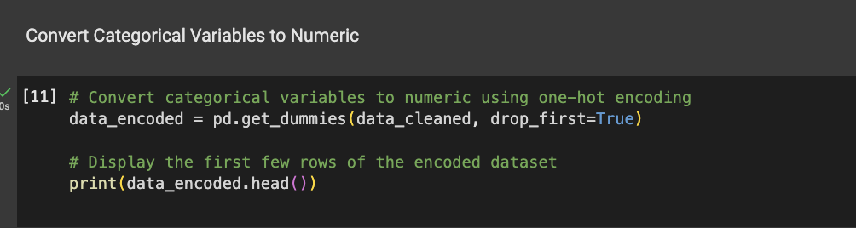

**Step 5: Correlation matrix with our target variable**

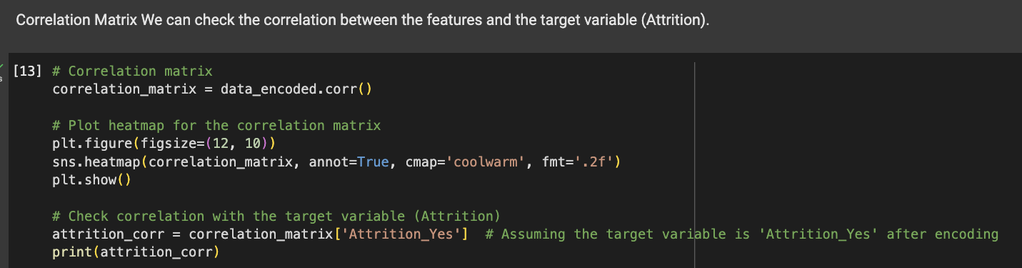

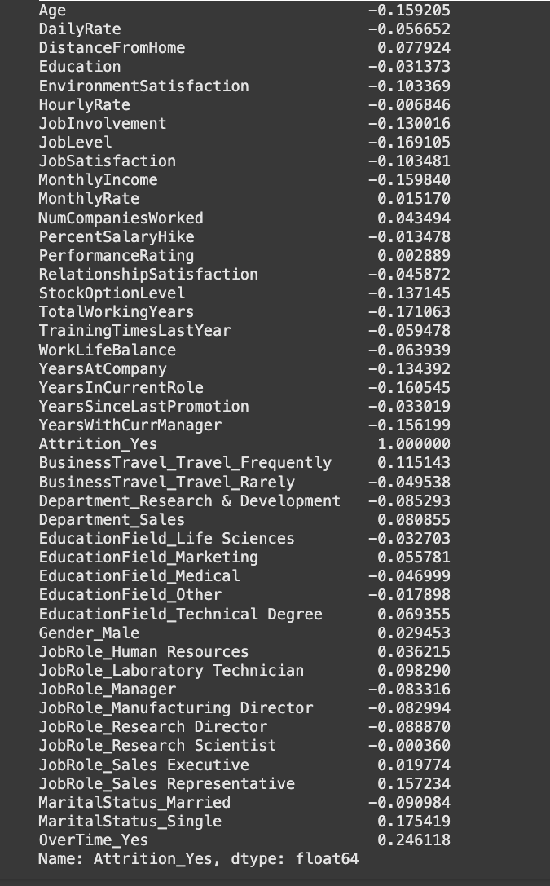**Result:**

### **Key Predictors and Feature Selection**

#### **Key Predictors**

The strongest predictors of employee attrition are:

* **OverTime (Yes):** Importance Score = 0.246
* **Marital Status (Single):** Importance Score = 0.175
* **Job Role (Sales Representative):** Importance Score = 0.157

These features significantly influence attrition risk and should be prioritized in the model.

#### **Moderate and Weak Features**

* **Moderately Correlated:** Features like **Job Level**, **Total Working Years**, and **Years at Company** show negative correlations, indicating lower attrition among experienced employees. Retain these for predictive value.
* **Weakly Correlated:** Features such as **Gender (Male)**, **Performance Rating**, and **Education Field** can be removed to reduce noise.

#### **Feature Engineering**

Combine related features (e.g., **Job Level** and **Years at Company**) to enhance model performance. Interaction terms can also capture complex relationships.

#### **Model Refinement**

Use machine learning models like **Random Forest** to evaluate feature importance and refine predictions. This ensures the model focuses on the most critical predictors while remaining efficient.

**Step 6: Dropping all irrelevant columns/ features**

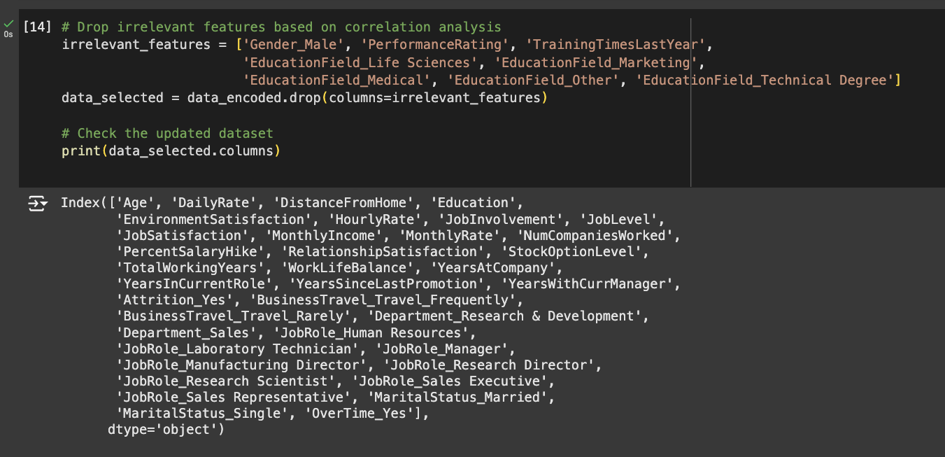

**Step 7: Again, running feature importance using RF**

**Feature Selection for Predicting Employee Attrition**

Feature selection is a critical step in building an effective predictive model for employee attrition. By identifying and prioritizing features based on their importance scores, we can enhance the model's accuracy while minimizing complexity.

#### **Top Features to Retain**

The following features have the highest importance scores and should be prioritized in the model as they significantly impact attrition prediction:

* **Monthly Income:** Importance Score = 0.091281
* **OverTime (Yes):** Importance Score = 0.071939
* **Age:** Importance Score = 0.059571
* **Daily Rate:** Importance Score = 0.056600
* **Monthly Rate:** Importance Score = 0.053558

These features provide critical insights into employee compensation, workload, and demographic factors, making them indispensable for the model.

#### **Moderate Features to Consider**

The following features, while not as impactful as the top features, still hold moderate importance and contribute positively to the model’s performance. They should be retained for better predictive accuracy:

* **Hourly Rate**
* **Distance From Home**
* **Total Working Years**
* **Years at Company**

These features capture additional aspects of employee work conditions and experiences, offering complementary information for attrition prediction.

#### **Lower Importance Features**

Features with lower importance scores have a minimal impact on the model's performance. These can either be removed or their impact minimized to streamline the model:

* **Job Role (Research Director): Importance Score = 0.000706**
* **Job Role (Manager): Importance Score = 0.001333**
* **Marital Status (Married): Importance Score = 0.007711**

#### **Potentially Removable Features**

The following features have very low importance and can be considered for removal, as their contribution to model accuracy is negligible:

* **Job Role (Human Resources)**
* **Business Travel (Travel Rarely)**
* **Job Role (Manufacturing Director)**

By eliminating these low-impact features, the model can be simplified without compromising its predictive power.

**Step 8: Bivariate analysis**

* Monthly income vs Attrition and DailyRate

* Age vs attrition

*Since this is a classification problem; we will choose three models namely :*

***Logistic regression, Random Forrest and XGBoost model for our modeling***

**Step 9: Modeling**

### **Logistic Regression Implementation**

#### **Implementation Overview**

Logistic Regression is a key classification algorithm used to predict binary outcomes. The implementation involves several stages, starting from data preparation to model evaluation.

* The process begins with **importing necessary libraries** such as pandas, numpy, sklearn (for model training, scaling, evaluation metrics, and cross-validation), and visualization libraries like matplotlib and seaborn.
* Key features are selected for modelling based on their importance scores. Feature engineering is performed by creating a new variable, **Age_TotalWorkingYears**, which combines the interaction between age and work experience. The data is then split into training and testing sets (80-20 split), followed by **standardization** using StandardScaler to ensure all features have comparable scales, optimizing the model's performance.

#### **Model Training and Evaluation**

* The Logistic Regression model is trained on the standardized training data using LogisticRegression from sklearn. Its performance is initially evaluated on the test set using a **classification report**, which includes precision, recall, and F1-score. To ensure robust generalization, a **5-fold cross-validation** is performed, providing a better understanding of the model’s stability.
* Hyperparameter tuning is carried out using **GridSearchCV**, optimizing parameters like C (regularization strength) and penalty. The best-performing model is then evaluated, and its results are compared with the untuned model using metrics like precision, recall, and F1-score.

#### **Visualization and Analysis**

* Key visualizations are generated to analyze model performance. **Feature importances** are derived from the logistic regression coefficients and plotted to understand which features most influence the predictions. **Confusion matrices** are created before and after tuning to observe changes in prediction accuracy. **ROC curves** are plotted to compare the true positive and false positive rates of the model at different thresholds, both before and after tuning.
* Finally, the metrics from the initial and tuned models are compared using visualizations, such as bar charts, highlighting improvements achieved through hyperparameter optimization.

By following these streamlined steps, the Logistic Regression model is effectively implemented, refined, and analyzed for optimal performance.

**Performance**

**Before Tuning:**

* Accuracy: 0.87
* Precision: High for negative class (0.89), low for positive class (0.53)
* Recall: Excellent for negative class (0.96), poor for positive class (0.26)
* F1-Score: Strong for negative class (0.93), weak for positive class (0.34)
* Macro Average: Recall = 0.61, F1 = 0.64, indicating class imbalance.
* Cross-Validation: Scores between 0.85 and 0.91, average = 0.87, indicating stable but improvable performance.

**After Tuning:**

* Best Hyperparameters: C=10, max_iter=100, penalty='l1', solver='saga'
* Accuracy: Slightly decreased to 0.86
* Precision: No change for negative class (0.89), slight drop for positive class (0.48)
* Recall: Unchanged for negative class (0.96), low for positive class (0.26)
* F1-Score: Slight drop for positive class (0.33), stable for negative class (0.92)
* Macro Average: Small drop in precision (0.71 to 0.68) and F1 (0.64 to 0.63).
* Key Observations: Class imbalance remains a major issue; tuning did not significantly improve the detection of positive instances.

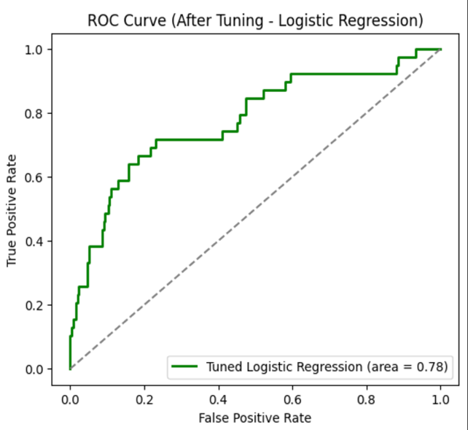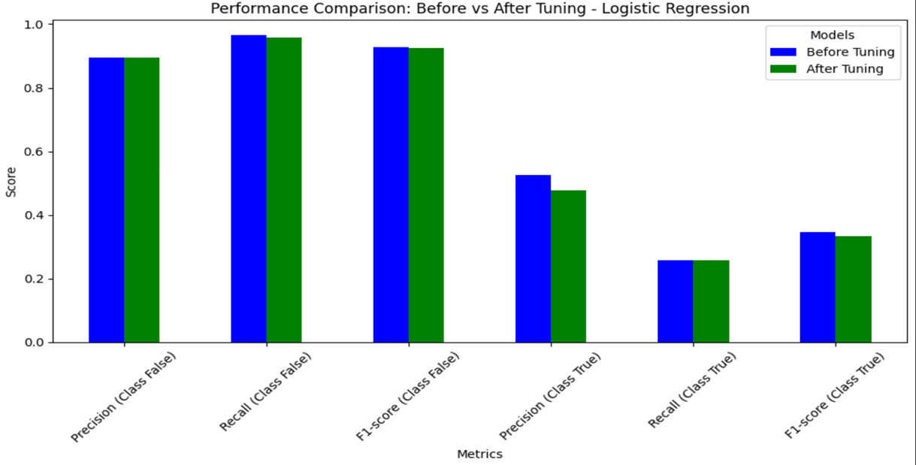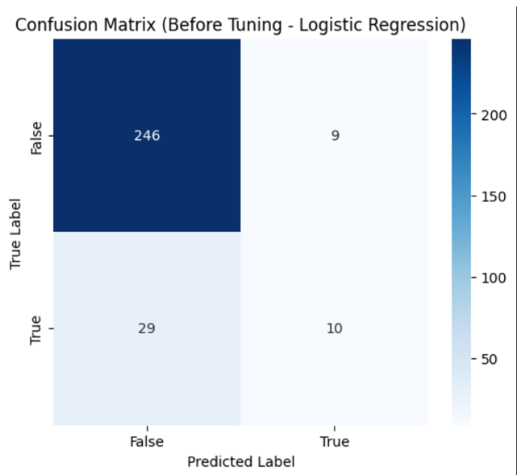

**Similarly, we created models for Random Forest and XGBoost as well:**

*Code mentioned in .py file*

**Random Forrest Implementation**

**Before Tuning (Random Forest Model Performance)**

* Accuracy: 87% – High overall accuracy, but this can be misleading due to class imbalance. Precision for True (Attrition=Yes): 0.67 – When predicting positive cases, the model is correct 67% of the time. Recall for True: 0.10 – The model struggles to detect most positive cases, indicating low performance on the minority class.
* F1-Score for True: 0.18 – Very low, reflecting poor balance between precision and recall.

**Macro Average:**

* Precision: 0.77
* Recall: 0.55
* F1-Score: 0.55

These metrics indicate that while the model performs well for the majority class, its performance on the minority class is poor.

**After Hyperparameter Tuning (Best Model Settings)**

Best Hyperparameters:

* max_depth: None
* min_samples_leaf: 1
* min_samples_split: 2
* n_estimators: 200

**Performance After Tuning:**

* Recall for True (Attrition=Yes): 0.10 – Still very low, indicating that the model still fails to detect most positive cases.
* Precision for True: 0.57 – Slight improvement over the un-tuned model but still suboptimal. F1-Score for True: 0.17 – Small improvement, but still very low.
* Accuracy: 87% – Remains unchanged from before.
* Weighted Average Metrics: Precision: 0.84 Recall: 0.87
* F1-Score: 0.83

These values reflect a good overall performance but still mask the issues with the minority class.

**Feature Importances (Most to Least Important)**

* MonthlyIncome: 0.085
* OverTime_Yes: 0.071
* Age_TotalWorkingYears: 0.071
* DailyRate: 0.058 Age: 0.056

**Others (lower importance):**

StockOptionLevel, JobSatisfaction, JobRole_Sales Representative, etc.

**XGBoost Implementation**

The results indicate the following:

**Before Hyperparameter Tuning:**

* Overall Accuracy: 85%
* Precision and Recall:
* False Class (Majority): High precision (0.88) and recall (0.95).
* True Class (Minority): Precision is low (0.35) with a recall of 0.18, indicating poor performance in identifying the minority class.
* Macro Average F1-Score: 0.58, showing a significant imbalance in class performance.

**After Hyperparameter Tuning:**

* Overall Accuracy: Improved to 87%.
* Precision and Recall:
* False Class (Majority): Slight improvement in both precision (0.89) and recall (0.97).
* True Class (Minority): Precision improved to 0.53, but recall remains low at 0.23.
* Macro Average F1-Score: Increased to 0.62, indicating modest improvement in handling class imbalance.

**Overall Results:**

|  |  |  |  |  |  |  |
| --- | --- | --- | --- | --- | --- | --- |
| **Model** | **Accuracy** | **Precision (True)** | **Recall (True)** | **F1-Score (True)** | **Macro Avg. F1-Score** | **Weighted Avg.  F1-Score** |
| **Logistic Regression** (Before Tuning) | 0.87 | 0.53 | 0.26 | 0.34 | 0.64 | 0.85 |
| **Random Forest** (Before Tuning) | 0.87 | 0.67 | 0.10 | 0.18 | 0.55 | 0.83 |
| **XGBoost** (Before Tuning) | 0.85 | 0.35 | 0.18 | 0.24 | 0.58 | 0.83 |

* Logistic Regression provides the best performance in terms of accuracy and balanced F1-score for the True class, though the recall is still low.
* Random Forest has the highest precision for the True class but very poor recall.
* XGBoost shows lower performance overall with poor precision and recall for the True class.

### **Addressing Class Imbalance in Classification Models**

Class imbalance poses significant challenges for machine learning models, particularly when predicting outcomes for the minority class. Below are strategies to improve performance on the positive (minority) class:

1. **Resampling Techniques**
   * **Oversampling:** Increase the number of samples in the minority class by duplicating existing instances or generating synthetic examples (e.g., using SMOTE).
   * **Undersampling:** Reduce the number of samples in the majority class to balance the dataset, ensuring that the model does not overfit to the majority class.
2. **Class Weights**
   * Assign higher weights to the minority class in the loss function to penalize misclassifications of positive instances. This approach ensures the model places greater importance on correctly classifying minority class samples.
3. **Threshold Adjustment**
   * The default classification threshold (typically 0.5) may not be optimal for imbalanced datasets. Lowering the threshold can improve recall for the positive class, increasing the likelihood of correctly identifying minority class instances.

By implementing these techniques, the model’s ability to handle class imbalance improves, leading to better overall performance, particularly for the minority class.

### **Future Scope**

1. **Integration with Flask APIs for Real-Time Predictions**  
   The employee attrition prediction model can be enhanced by incorporating **Flask APIs** to facilitate seamless communication between backend and frontend interfaces. Flask APIs would enable real-time predictions and insights to be delivered to HR managers through an interactive dashboard. This would provide an intuitive way to visualize department-level trends, identify risk factors, and implement potential retention strategies effectively.
2. **Incorporating External Data Sources**  
   Future improvements could involve integrating external datasets such as **industry-specific trends**, **economic factors**, and **social media sentiment analysis**. These data sources could improve the accuracy of attrition predictions by accounting for broader contextual factors. Flask APIs would ensure the system can process and transmit real-time data updates and deliver personalized recommendations, adapting dynamically to changing organizational and market conditions.
3. **Advanced Machine Learning Techniques**  
   The use of **deep learning** and other advanced machine learning techniques could allow the model to capture complex patterns in employee behavior. By deploying these sophisticated models through Flask APIs, HR teams could dynamically experiment with interventions (e.g., flexible work hours or targeted training programs) and observe their impact on attrition risks in real-time.
4. **Seamless Integration with HR Tools**  
   Flask APIs could enable integration with existing HR systems to create a unified, interactive platform. This integration would allow retention strategies to be automatically aligned with organizational goals, streamlining workforce management. A cohesive system would empower HR teams to make data-driven decisions, ultimately reducing employee turnover and fostering a more engaged and stable workforce.